**CCMP 606 - Orchestration of Cloud Resources  
Assignment 1 Report**

Instructor: **Yongchang He**

Student: **Hai Nam Nguyen – 000520322**

2023/2024 Winter Semester

Saskatchewan Polytechnic

Submitted:

**January 29th, 2024**

Table of Contents

I. Compile PiggyBank.sol 3

II. Sepolia ETH on MetaMask 5

III. Smart Contract Address on the Etherscan Webpage 6

IV. Contract Balance on Remix IDE 6

V. Explanations and Show How the Functions Work 8

# Compile PiggyBank.sol

The screenshot(s) show PiggyBank.sol has no compile errors on Remix IDE. (0.5 points)

Compile:

Deploy:

First, check the Injected Provider – MetaMask account

Secondly, click Deploying:

Lastly, Confirm to see the deploy success:

Double check on Sepolia etherscan:

# Sepolia ETH on MetaMask

Get faucet from [https://sepoliafaucet.com/](mailto:https://sepoliafaucet.com/)

# Smart Contract Address on the Etherscan Webpage

The address: [https://sepolia.etherscan.io/address/0xc0226a9ad5535406250cb26727dfc28b4c58a634](mailto:https://sepolia.etherscan.io/address/0xc0226a9ad5535406250cb26727dfc28b4c58a634)

# Contract Balance on Remix IDE

After deposit:

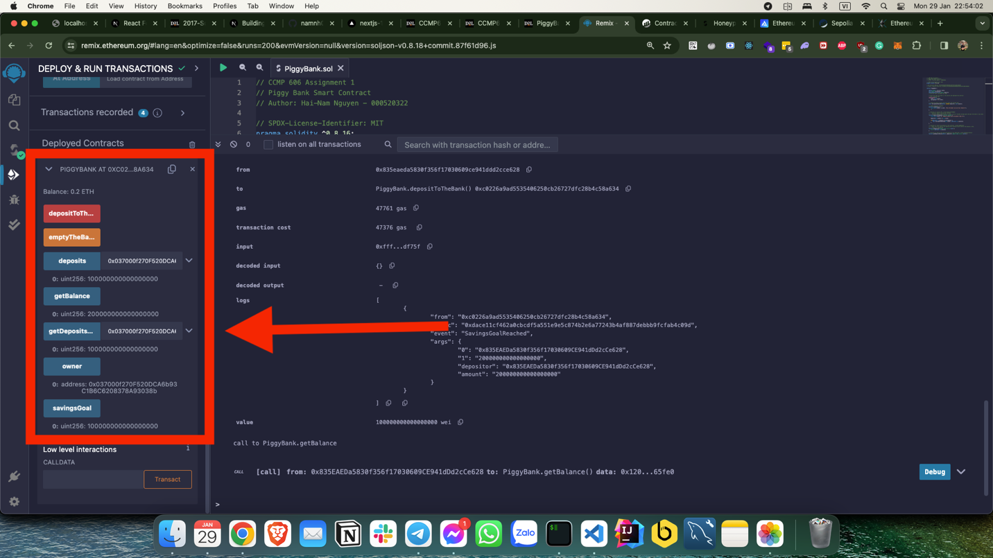

Also on Sepolia Etherscan:

# Explanations and Show How the Functions Work

1. Function depositToTheBankA computer screen shot of text

   Description automatically generated

Overview, this function check how much the ether will be sent to the contract, it must be greater than 0 otherwise the error log will display. After require check, the mapping deposits will store the address of who send ether and cumulative the value he/she sent. The last one is the If condition to check whether the balance of this contract is equal or larger than savingsGoal or not. If yes, the event SavingsGoalReached will be emitted.

1. Function getBalance

This function can be called by anyone and return the balance of this contract in wei.

1. Function getDepositsValue

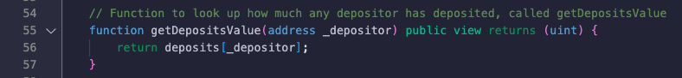

This function receives an address and return the wei that this address sent to the contract if exists.

1. Function emptyTheBank

This function stricted by onlyOwner can call.

It checks whether the balance of this contract is greater or equal the savingsGoal. If the balance matched condition, the ether in this contract will be transferred to the owner address.

After this function invoked, the contract address looks like this:

Functions worked:

